Bioconductor Spatial Data and Image Analysis Hackathon
  - Venice, April 2026
Helena Crowell
Luca Marconato
Ilaria Billato
Matteo Calgaro
Robert Castelo
Riccardo Ceccaroni
Carissa Chen
Patrick Danaher
Sean Davis
Martin Emons
Gabriel Grajeda
Hugo Gruson
Samuel Gunz
Juan Henao
Rafael Irizarry
Sviatoslav Kharuk
Daria Lazic
Artür Manukyan
Pere Moles-Seró
Elizabeth Purdom
Dario Righelli
Gabriele Sales
Mike L. Smith
Charlotte Soneson
Michael B. Stadler
Wolfgang Huber
Davide Risso
2026-05-18
Abstract
We report the outcomes of the Bioconductor Spatial Data and Image Analysis Hackathon, held in Venice, Italy in April 2026. Twenty-seven researchers and software developers organized into four teams to advance R/Bioconductor capabilities for spatial omics and image analysis. Outputs include scalable raster–polygon workflows for whole-slide pathology, an R package for running spatial foundation models via reticulate/basilisk, a spatially stratified differential expression framework, and substantial enhancements to the R SpatialData infrastructure for interoperability with the Python spatialdata ecosystem. All software is openly available and under active development.

1. Introduction
This manuscript documents the work performed at the Bioconductor Spatial Data and Image Analysis Hackathon, held in Venice, Italy in April 2026. The hackathon brought together 27 researchers and software developers to advance Bioconductor capabilities in spatial data handling, analysis, and image analysis. Work was organized into team projects spanning three days, with each team independently scoping and executing on a challenge important to its members.

1.1 Schedule and structure
Each day began at 09:00 with a brief plenary across all teams. Coffee breaks at 10:30 and 15:30, plus a 12:30–13:30 lunch, gave teams structured opportunities to compare notes. Days 1 and 2 ended at 17:00 with five-minute single-slide updates from each team. Day 1 also included a mid-day plan presentation right after lunch. The mid-day plan helped teams converge quickly on a focused project, with the explicit understanding that the plan would evolve over the next two days. The end-of-day summaries surfaced shared challenges and made cross-team progress visible.
Table 1: Daily schedule
Time | Activity
09:00 | Brief plenary with all teams
10:30 | Coffee break
12:30 – 13:30 | Lunch
13:30 (Day 1) | Initial project plan, one slide per team
15:30 | Coffee break
17:00 (Days 1–2) | End-of-day team summaries, one slide per team

Each team worked in a public GitHub repository created and maintained throughout the three days. The README.md was emphasized as the entry point, on the premise that future collaboration and visibility scale with a strong landing page.
Each team also designated a writer responsible for contributing to this manuscript. Author and conflict-of-interest information was collected in a shared spreadsheet for attribution. A short writers’ meeting on the morning of day 3 agreed on figure and text contribution mechanics; writers then worked with their teams through the afternoon to complete drafts before departing.

1.2 Hackathon teams
Participants self-organized into four teams:
- Image and segmentation data manipulation and visualization (Section 2)
- Spatial foundation models for the Bioconductor community (Section 3)
- Spatially stratified differential expression analysis (Section 4)
- Enhanced infrastructure and interoperability for spatial data in Bioconductor (Section 5)
The remainder of this manuscript reports each team’s work in a common four-part structure — motivation, methods, results, and discussion and next steps — followed by a cross-cutting discussion that draws out themes shared across the projects.

2. Image and segmentation data manipulation and visualization
Source code: https://github.com/drisso/segmentation-analysis

2.1 Motivation
Spatial omics and digital pathology have moved from low-plex imaging to gigapixel whole-slide datasets. These datasets typically pair multi-gigabyte whole-slide images (WSIs) with segmentation masks identifying hundreds of thousands to millions of nuclei or cell boundaries. The work reported here focuses on classical pathology images (hematoxylin and eosin, H&E), illustrated with an example from The Cancer Imaging Archive¹; the methodology generalizes to spatial transcriptomics data when H&E or immunofluorescence images accompany transcriptomic profiles, which is the case for most modern datasets.
The Python ecosystem offers powerful frameworks for spatial image processing, including spatialdata². R/Bioconductor has a comparably mature suite of geostatistical and geographical analysis tools — terra, sf³, and spatstat⁴ — but as image sizes and cell counts grow, R users hit a “raster–polygon bottleneck”: the inability to efficiently extract image features from massive rasters and intersect them with millions of polygons without exceeding system memory.
The core problem addressed here is enabling scalable image feature extraction in R. Bridging cloud-optimized image formats (Zarr) with high-performance spatial databases (GeoParquet) makes R’s specialized spatial-statistics tooling available to digital-pathology workloads at whole-slide scale. Building on the same foundation, an interactive Shiny + Plotly workflow lets users select arbitrary regions of interest (ROIs) directly from a tissue image and feed those polygons into the same lazy subsetting pipeline.

2.2 Methods
The methodological work targeted efficient reading and cropping of large OME-TIFF and Zarr images, and efficient subsetting of large polygon collections in R. The resulting pipeline prioritizes memory efficiency by never materializing more data than needed for a single processing window, using GeoParquet for polygon storage and OME-Zarr for image storage.

2.2.1 Example data
The test image is the H&E slide TCGA-02-0001-01Z-00-DX1.83fce43e-42ac-4dcd-b156-2908e75f2e47 from TCGA, retrieved via the imageTCGA Bioconductor package⁵. The original SVS image was converted into OME-TIFF and OME-Zarr; it has three channels (RGB) and 35,558 × 48,002 pixels, and the Zarr file contains 48 chunks of shape 3 × 6,688 × 6,688.
imageTCGA also provides nuclear segmentations from HoVer-Net⁶. Polygons are originally distributed as GeoJSON; a GeoParquet version was produced for this work. The polygon file contains 333,207 polygons, with a 2× scale factor between polygon and image coordinates (the polygons assume 40× magnification while the image is 20×).

2.2.2 Technical stack
Table 2: Components of the raster–polygon pipeline.
Component | Role | Reference
OME-Zarr | Cloud-optimized chunked image format used to store the H&E pixels. | zarr.dev
GeoParquet | Columnar polygon storage with bounding-box metadata for fast spatial filtering. | geoparquet.org
terra | Lazy raster loading and raster–vector intersection (originally for satellite imagery). | ⁷
DuckDB + duckspatial | Out-of-memory spatial filtering — query million-row polygon files as if they were a local database. | ⁸
ZarrArray | DelayedArray backend for native Zarr access within Bioconductor. | ^{9,10}

2.2.3 Algorithm
Rather than iterating over polygons (the “vector-first” approach), the algorithm iterates over the intrinsic Zarr chunks of the image (the “raster-first” approach). For each chunk $C_{i,j}$:
- Spatial fetch. A SQL query is pushed to the Parquet file to retrieve only polygons $P$ where $BBox(P)∩BBox(C_{i,j})≠∅$.
- Lazy read. The image data for $C_{i,j}$ is read into memory.
- Rasterize. The selected polygons are rasterized into a label mask.
- Compute. Per-channel pixel statistics (e.g., mean intensity) are computed for each labeled object.
The main difficulty is the border effect (Figure 1 A): each chunk should be read only once, but when a polygon straddles two chunks the in-memory pixel set for one chunk is incomplete. A pixel-accumulation strategy resolves this (Figure 1 B): when a polygon partially overlaps a chunk, the rasterized partial pixel set is stored under the polygon’s identifier; when the adjacent chunk is processed, the buffer is extended and statistics are computed only once the polygon is complete.
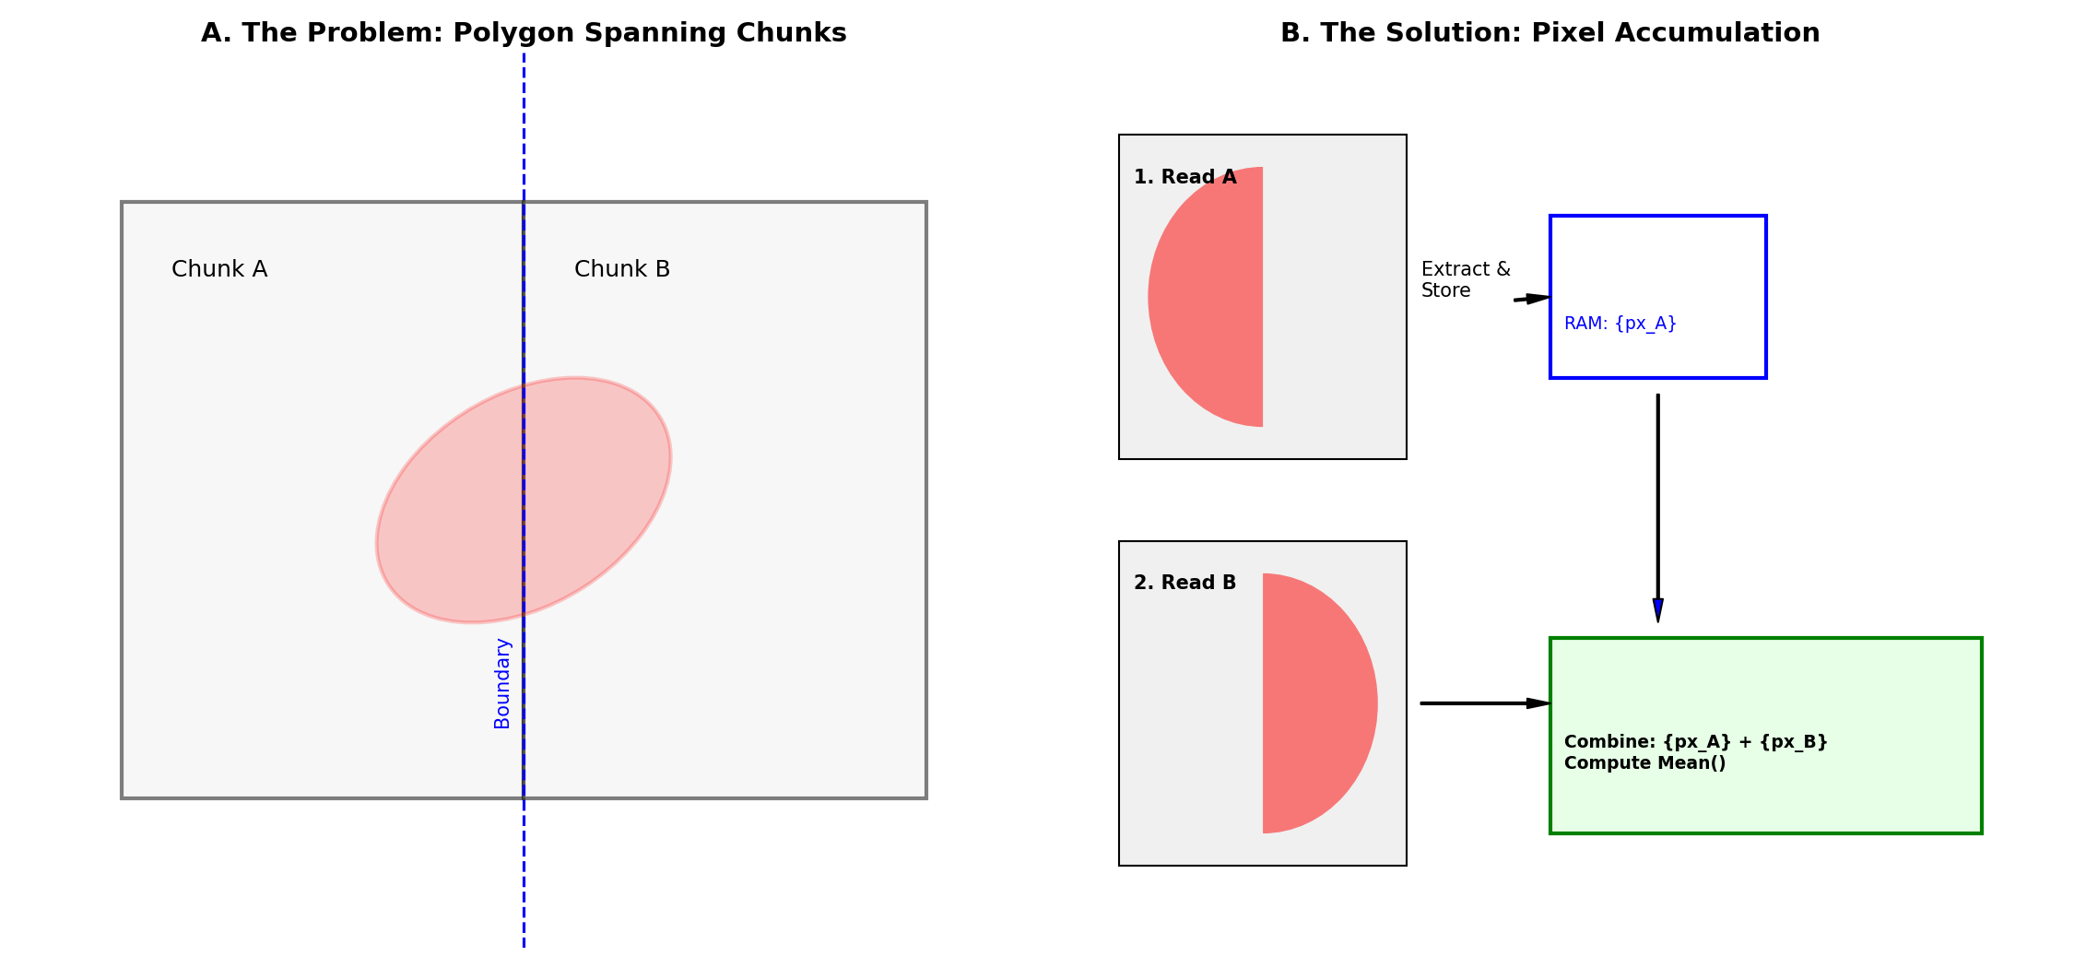
Figure 1: Schematic of the border effect and pixel-accumulation strategy. (A) A polygon straddles two Zarr chunks; processing one chunk at a time leaves incomplete pixel coverage. (B) A buffered accumulation strategy combines partial pixel sets from successive chunks before computing the final per-object statistic, without re-reading any chunk.

2.2.4 Interactive ROI selection
Building on the rasterisation primitives in terra, an interactive ROI-selection workflow uses plotly¹¹ to let users draw arbitrary polygons over a tissue image — demonstrated here on the mouse ileum profiled by MERFISH (accessed via ExperimentHub ID EH7543)^{12,13} as proof of concept. User-drawn polygons are returned as coordinate geometries and converted into spatial vector objects. The ROI is then materialized through the same lazy pipeline used elsewhere in the section: transcript coordinates are filtered with out-of-memory operations in duckspatial, and the underlying image is cropped with terra and visualised with tidyterra¹⁴.

2.3 Results

2.3.1 Random access to polygon files
Pushing spatial queries to an out-of-memory Parquet file substantially outperforms traditional GeoJSON-based workflows, enabling whole-slide analyses on standard workstations. While duckspatial works with both formats, polygon subsetting was approximately 50× faster on GeoParquet than on GeoJSON.

2.3.2 Cropping and visualization of large images
Reading, cropping, and visualizing large OME-TIFF images is efficient using terra’s rast() and crop(). For OME-Zarr, combining ZarrArray subsetting with terra::rast() works equally well. The intersection of high-speed polygon queries with high-resolution pathology crops is illustrated in Figure 2.
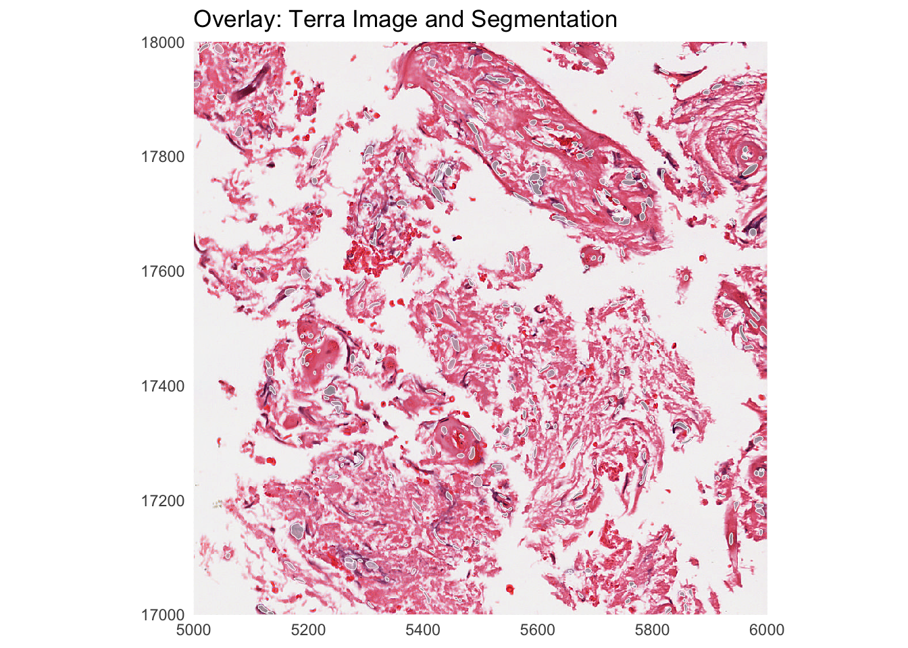
Figure 2: Overlay of segmentation polygons on a TCGA H&E whole-slide image crop, demonstrating the intersection of a lazily loaded Zarr image with polygons retrieved via spatial query from GeoParquet.

2.3.3 Mask creation and statistics computation
Combining the components above, a prototype implementation:
- iterates over Zarr image chunks,
- selects polygons overlapping each chunk,
- rasterizes them into an image mask, and
- computes mean per-channel pixel intensity over each segmented object.
On the example image, the analysis runs in $986±2$ seconds using R 4.5.3 on a MacBook Pro with an Apple M5 chip, 10-core CPU, 32 GB RAM, and local-SSD image data. The workflow reads only the relevant cell-boundary shapes and Zarr image data for each chunk, avoiding full-image materialization; loading the full image into memory on the same machine resulted in an out-of-memory error.

2.3.4 Interactive ROI selection in practice
The Shiny + Plotly application described in Methods exposes the lazy subsetting pipeline through a point-and-click interface: an analyst draws an arbitrary polygon over a tissue image, the polygon coordinates are exported as a spatial vector object, and the underlying image and spatial-transcriptomics data are subset to that region for visualisation and downstream analysis of tissue compartments.

2.4 Discussion and next steps
The combination of OME-Zarr image storage, GeoParquet polygon storage, and DuckDB spatial queries makes whole-slide pathology analysis tractable in R on commodity hardware, without rewriting the underlying spatial-statistics tooling. Pushing predicates into chunked, indexed storage rather than loading data into R is the central design choice, and the same pattern recurs across the other hackathon teams.
The current prototype skips polygons that straddle multiple chunks, sidestepping the border effect described in Figure 1. Implementing the full pixel-accumulation strategy is the natural next step. Additional priorities are packaging the chunk-iteration loop into reusable utilities, validating performance on larger and more diverse datasets, and integrating the workflow with downstream Bioconductor packages for cell-level analysis.

3. Spatial foundation models for the Bioconductor community
Source code: https://github.com/drighelli/fomo

3.1 Motivation
Foundation models for spatial data are predominantly distributed as Python packages, and configuring them for a particular compute environment is often fragile: most have specific version dependencies that are not always documented, even when the model is on PyPI. This makes individual models hard to install for many R users and makes reproducible benchmarking across models onerous. A second gap is representational: most Python tools expect AnnData, while the natural Bioconductor container for spatial data is SpatialExperiment, so any reusable wrapper has to reconcile the two. The fomo package addresses both problems.

3.2 Methods

3.2.1 Package design
fomo configures and runs foundation-model pipelines from R. It uses basilisk and reticulate to build separate environments per model (Figure 3), avoiding the dependency conflicts that arise when attempting to satisfy all models in a single environment. The package ships a collection of BasiliskEnvironment schemas that pin a Python version and the required PyPI dependencies for each model. For models not on PyPI, fomo provides template scripts to build environments via reticulate.
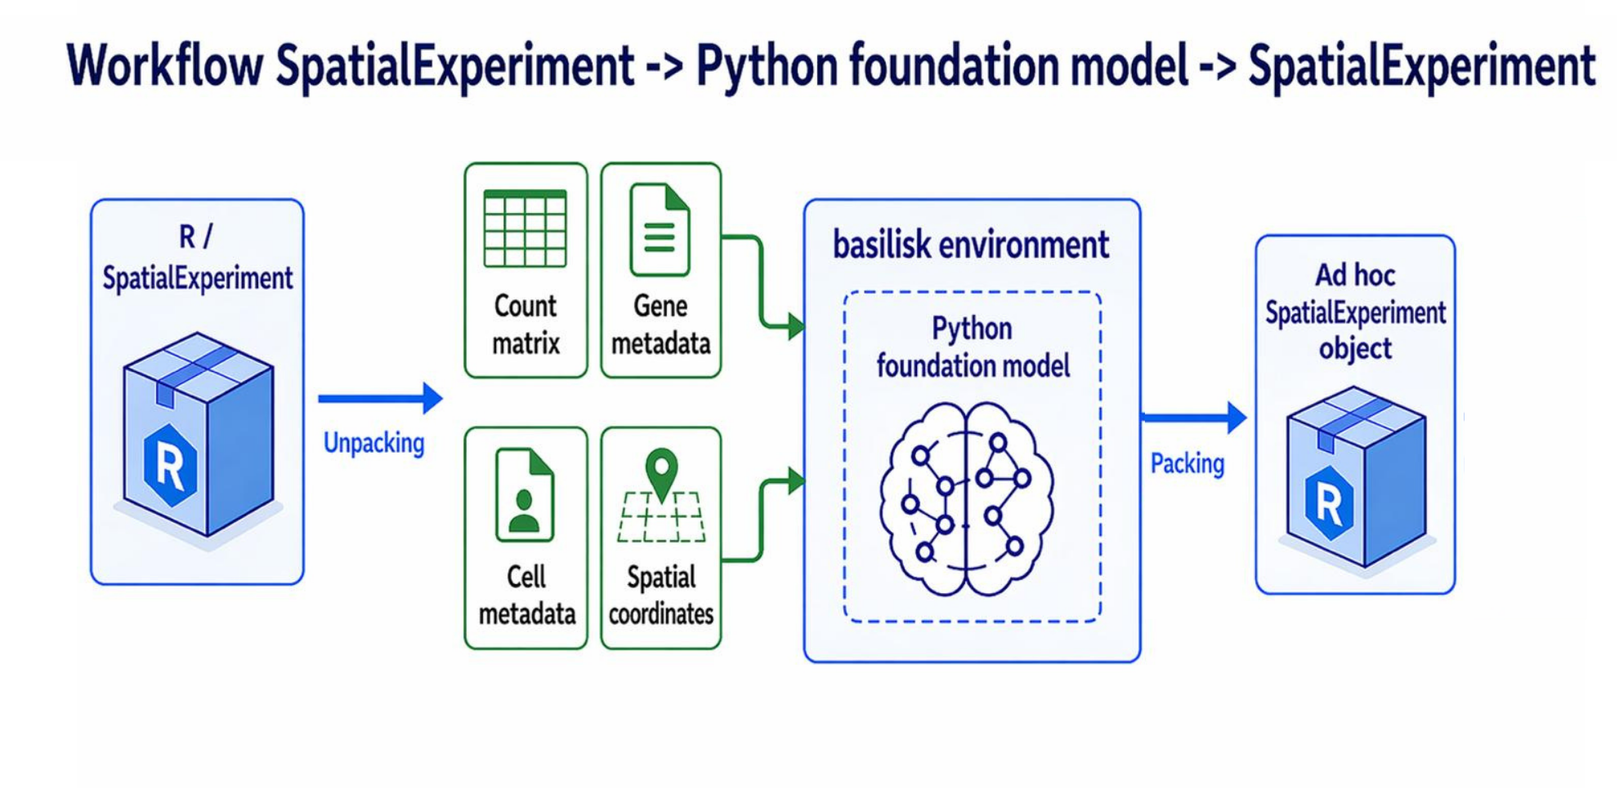
Figure 3: Schematic of the fomo package. Input data in SpatialExperiment is fed to functions that set up isolated Python environments via reticulate, run the model, and return embeddings into the SpatialExperiment object.
For each supported model, the package exports a Run_<model>() function (e.g., Run_novae()). The package focuses on zero-shot use of pre-trained models: input data are passed in and embeddings come back, with no fine-tuning required. The final design takes a SpatialExperiment as input and writes embeddings to its reducedDims slot.

3.2.2 Models
Six models spanning the breadth of current spatial-foundation use cases were prioritized (Table 3). Wherever possible, weights are pulled from Hugging Face so the entire workflow runs through the package; the exception is scGPT, which uses upstream PyTorch checkpoints.
Table 3: Models packaged in fomo. ✅ = exposed via Run_*(), 🟡 = environment recipe shipped but no wrapper yet, ❌ = not currently runnable through the package.
Status | Model | Category | PyPI | Primary input | Output | Embedding size
✅ | scGPT¹⁵ | Single-cell transcriptomics | ✅ | Gene counts | Cell embeddings | 512
🟡 | scFoundation¹⁶ | Single-cell transcriptomics | ✅ | Gene counts | Gene / cell embeddings | 3072
✅ | Novae¹⁷ | Spatial transcriptomics | ✅ | Gene counts + spatial coords | Neighbor-context embedding + zero-shot domains | 64
🟡 | Prov-GigaPath¹⁸ | H&E imaging | ❌ | H&E WSI tiles | Tile / slide embeddings | tile 1536, slide 768
✅ | Nimbus¹⁹ | Spatial proteomics | ✅ | Multiplex TIFF + segmentation mask | Per-cell expression estimates and annotations | —
❌ | KRONOS²⁰ | Spatial proteomics | ❌ | TIFF + mask + marker annotation | Per-patch embeddings | 384

scGPT. Although not designed for spatial data, transcriptional profiles from spatial assays can be passed through it for comparison with spatial-specific models. (A spatial extension is available²¹ but not yet integrated.) The implementation uses upstream PyTorch checkpoints (.pt plus support .json files) rather than the Hugging Face port, because scGPT distributes multiple pretrained checkpoints and working with them directly preserves user choice. Run_scGPT() takes the path to an .h5ad file and the directory containing the pretrained model.
Novae. Embeddings are accessible from the returned AnnData at adata$obsm$novae_latent and domain assignments at adata$obs$novae_domains_7. Novae runs on CUDA GPUs and Apple Metal Performance Shaders (MPS).
Prov-GigaPath. Integration is in progress. The current blocker is provisioning the Python environment on remote GPU servers: the required Python build is slow to download and a robust install pattern for that setting is still being worked out.
Nimbus. Operates marker by marker across the multiplexed image, which makes it portable across multiplexed-imaging platforms with different channel counts.

3.2.3 SpatialExperiment ↔ AnnData conversion via anndataR
Because most Python tools expect AnnData, anndataR was extended to support bidirectional conversion between SpatialExperiment and AnnData — layering a spatially aware translation on top of the existing SingleCellExperiment conversion framework. Canonical mappings for assays, feature- and cell-level annotations, dimensionality reductions, and graph-like pairwise structures are preserved; the new logic adds explicit handling for spatial state. Forward (R → Python), spatialCoords are serialized to obsm["spatial"] and image metadata from imgData is written to uns["spatial"] in a library-indexed nested layout compatible with Scanpy conventions; in reverse (Python → R), those structures are parsed to reconstruct SpatialExperiment objects with restored coordinates and images.
The central difficulty is that SpatialExperiment carries semantics that are not native to AnnData: spatial coordinates are not generic embeddings, image metadata are heterogeneous and partially technology-specific, and multi-library datasets require deterministic reconciliation between observation-level sample annotations and image-level library identifiers. Reserved spatial keys, conflict checks against user-defined obsm and uns mappings, and a round-trip metadata container under uns["anndataR_spatialexperiment"] together preserve otherwise non-canonical information (original coordinate names, selected spatial keys, library identifier provenance, image export mode). Image payloads can be embedded, referenced, or omitted to balance interoperability, file size, and reversibility.
The current development branch can be installed with:
remotes::install_github("drighelli/anndataR@from_as_spe")

3.3 Results
This section reports two complementary results: a use case demonstrating zero-shot application of a current spatial-proteomics foundation model (KRONOS), and a status report on the SpatialExperiment ↔ AnnData conversion that underpins R-side use of all the wrapped models.

3.3.1 KRONOS use case
KRONOS²⁰ is a foundation model purpose-built for spatial proteomics. It was trained on more than 47 million image patches covering 16 tissue types and 175 protein markers, and uses a Vision Transformer based on DINOv2 modified to handle highly multiplexed images. KRONOS extracts 384-dimensional embeddings for each patch, which can be used for cell phenotyping, artifact detection, or outcome prediction.
Because KRONOS is not distributed as a Python package, it does not yet fit the fomo envelope and was instead explored directly in a use case of interest. Starting from a multiplexed image with ~56 channels (Figure 4), KRONOS was applied to 128 × 128 sliding windows to obtain feature vectors. PCA of these embeddings, viewed spatially as RGB-mapped per-window boxes, immediately surfaces a clear image artifact (Figure 5).
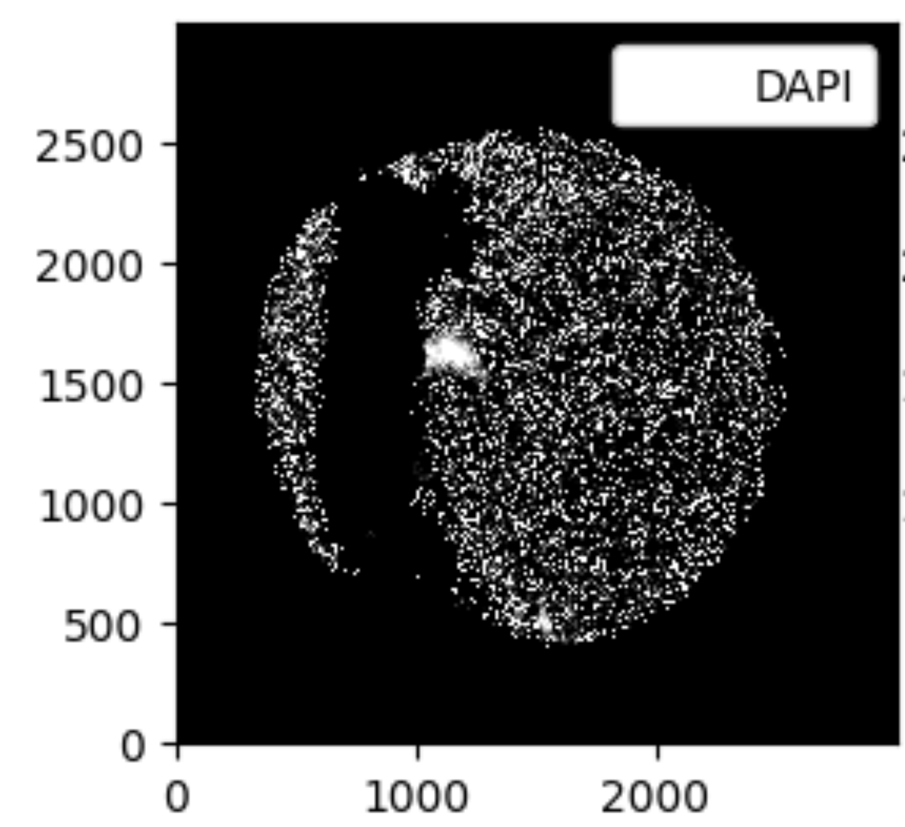
Figure 4: Original DAPI channel of the multiplexed input image.

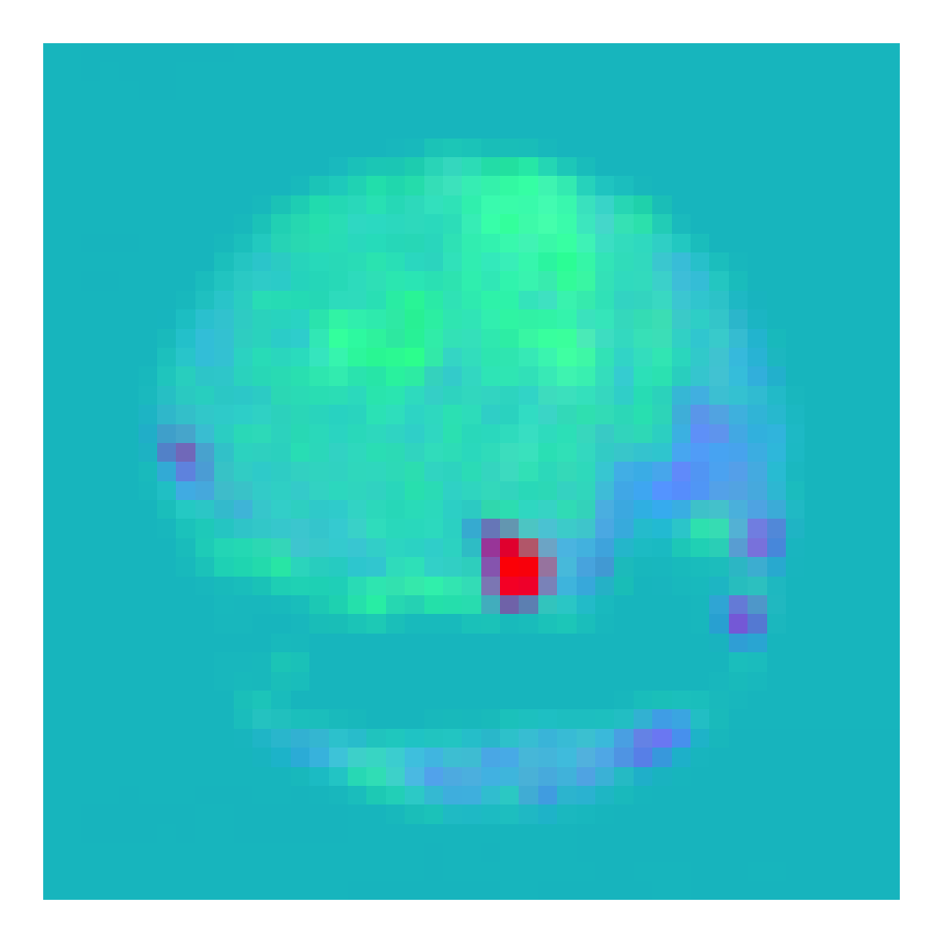
Figure 5: First three principal components of the KRONOS feature vectors, mapped to RGB and laid out in their original spatial positions. The pattern strongly indicates an image artifact.

3.3.2 Conversion testing
Preliminary evaluation of the SpatialExperiment ↔ AnnData converter surfaces discrepancies in specific configurations, particularly those involving technology-specific spatial metadata or image representations. The reproducibility case study in the renovae repository (https://github.com/sales-lab/renovae) documents one such mismatch and helps locate the remaining failure points before the work is upstreamed as a pull request to anndataR.

3.4 Discussion and next steps
The fomo envelope reduces the per-model setup burden to a package install for the models it covers, and the anndataR extension closes the representational gap between SpatialExperiment and AnnData for the spatial state Python tools depend on. Continued work falls into three areas: completing the wrappers for scFoundation and Prov-GigaPath; designing a robust pattern for models distributed outside PyPI (KRONOS in particular); and resolving the remaining SpatialExperiment ↔ AnnData round-trip discrepancies before upstreaming the converter. A standardized benchmarking interface across models is the natural follow-on once the wrapper set is complete.

4. Spatially stratified differential expression analysis
Source code: https://github.com/mcalgaro93/SpatialStratifiedDE

4.1 Motivation
Spatial data are a powerful platform for differential expression (DE) analyses, letting analysts interrogate how a given cell type changes phenotype or expression in response to its environment — for example, how tumor cells respond to T-cell attack, or how fibroblast expression changes in regions of tissue damage.
This kind of phenotype–environment DE testing is typically performed at the level of whole studies or whole tissues. That has two important limitations. First, it ignores spatial autocorrelation in gene expression, leading to biased estimates and overconfident standard errors. Second, it ignores the fact that correlations can be heterogeneous across a tissue: tumor cells, for example, may use different pathways in response to T-cell attack under different local conditions. Spatial datasets are now large and rich enough to support DE questions at finer resolution than the entire tissue.
The proposal pursued here is to split the tissue into dozens or hundreds of small patches and run DE separately in each, revealing the precise regions where a given DE pattern occurs. Individual patches may be underpowered, so a spatially smoothed meta-analysis recovers confidence: for each patch the $K$ most similar patches are identified — by underlying traits such as cell-type composition rather than by their DE results — and DE results are meta-analyzed across that neighborhood, regaining statistical power lost to fine-grained stratification.

4.2 Methods
The full workflow chains five stages, summarized in Figure 6: patches are defined from cell coordinates and the design variable; per-patch DE is run via ordinary least squares (OLS); each patch is described by a “spatial-context” feature vector; per-patch results are stabilized by meta-analysis across nearest neighbors in that feature space; and the resulting patch × gene matrix is the substrate for downstream biological exploration.
Figure 6: Spatially stratified DE pipeline. Each box corresponds to one Methods subsection below.

4.2.1 Patch definition
getPatches() defines patches via an iterative algorithm that incrementally adjusts patch borders to ensure adequate statistical power everywhere. Patches are scored by the sum of squares of the design variable, which determines OLS power; at each iteration, low-power patches expand into higher-power neighbors, gradually homogenizing per-patch power. In the simplest mode, only the target cell type’s xy coordinates and design variable values are required.
A more nuanced variant was also explored: ideal patches have high variance in the design variable while being homogeneous in everything else, which controls confounding. This variant first applies standard spatial clustering to partition the tissue into niches or spatial domains and then runs getPatches() within each domain. The resulting patches are more internally homogeneous (they do not span domains), at some cost in maximum achievable power; the trade-off is expected to be worthwhile because within-patch confounding is the more dangerous failure mode.

4.2.2 Stratified DE
For each patch, patchDE() performs OLS for all genes via a single matrix multiplication, producing complete per-patch DE results in seconds. This efficiency matters: a typical study might involve >18,000 genes and >1,000 patches.

4.2.3 Characterizing patches
Meta-analysis requires a definition of “spatial context” — a matrix encoding each patch in a reasonable number of features. Several reasonable choices are available, depending on the study design:
- Mean gene expression across all cells (or just the target cell type) per patch, optionally reduced to ~50 PCs.
- Cell-type abundances per patch.
- Per-patch averages of cell-level PCA embeddings, optionally with within-patch variance.
- Per-patch averages of foundation-model embeddings (e.g., Novae) over cells.
The right choice is a design question for the analyst.

4.2.4 Unsupervised subgroup meta-analysis
Given per-patch DE estimates and standard errors plus the patch-characteristics matrix, each patch’s $K$ nearest neighbors in patch-characteristic space — intended to be biologically similar — are identified, and a meta-analysis is performed across the patch and its neighbors. The unstable per-patch estimate is replaced with a more precise, more confident regional estimate.

4.2.5 Pursuing biological understanding
The output is a matrix of DE results for all patches × genes, which is rich but daunting. The intended downstream analyses include subgroup analyses (drawn from clinical-trial methodology) that surface well-characterized regions where a gene’s DE signal is strongest or where results most diverge from the average patch; clustering genes into modules and patches into groups by DE profile; and association of per-patch DE results with covariates such as pathologist annotations or local cell-type abundance.

4.3 Results
A prototype of the SpatialStratifiedDE pipeline was applied to two spatial datasets: a mouse colon MERFISH dataset²² used to study how colon epithelial cells change with proximity to T cells after three days of DSS-induced colitis, and a colon-cancer spatial transcriptomics dataset²³ used to study how tumor cells change with proximity to T cells. Together these illustrate how patch-wise DE combined with spatially smoothed meta-analysis surfaces localized, high-confidence DE patterns.

4.3.1 Iterative algorithm yields patches with reasonable power
Figure 7 shows the improvement of patch power over iterations of getPatches() on epithelial cells of the mouse colon MERFISH dataset²². Top panels show patch footprints at the first and final iterations; bottom panels show each patch’s sum of squares of the predictor variable, which determines DE statistical power.
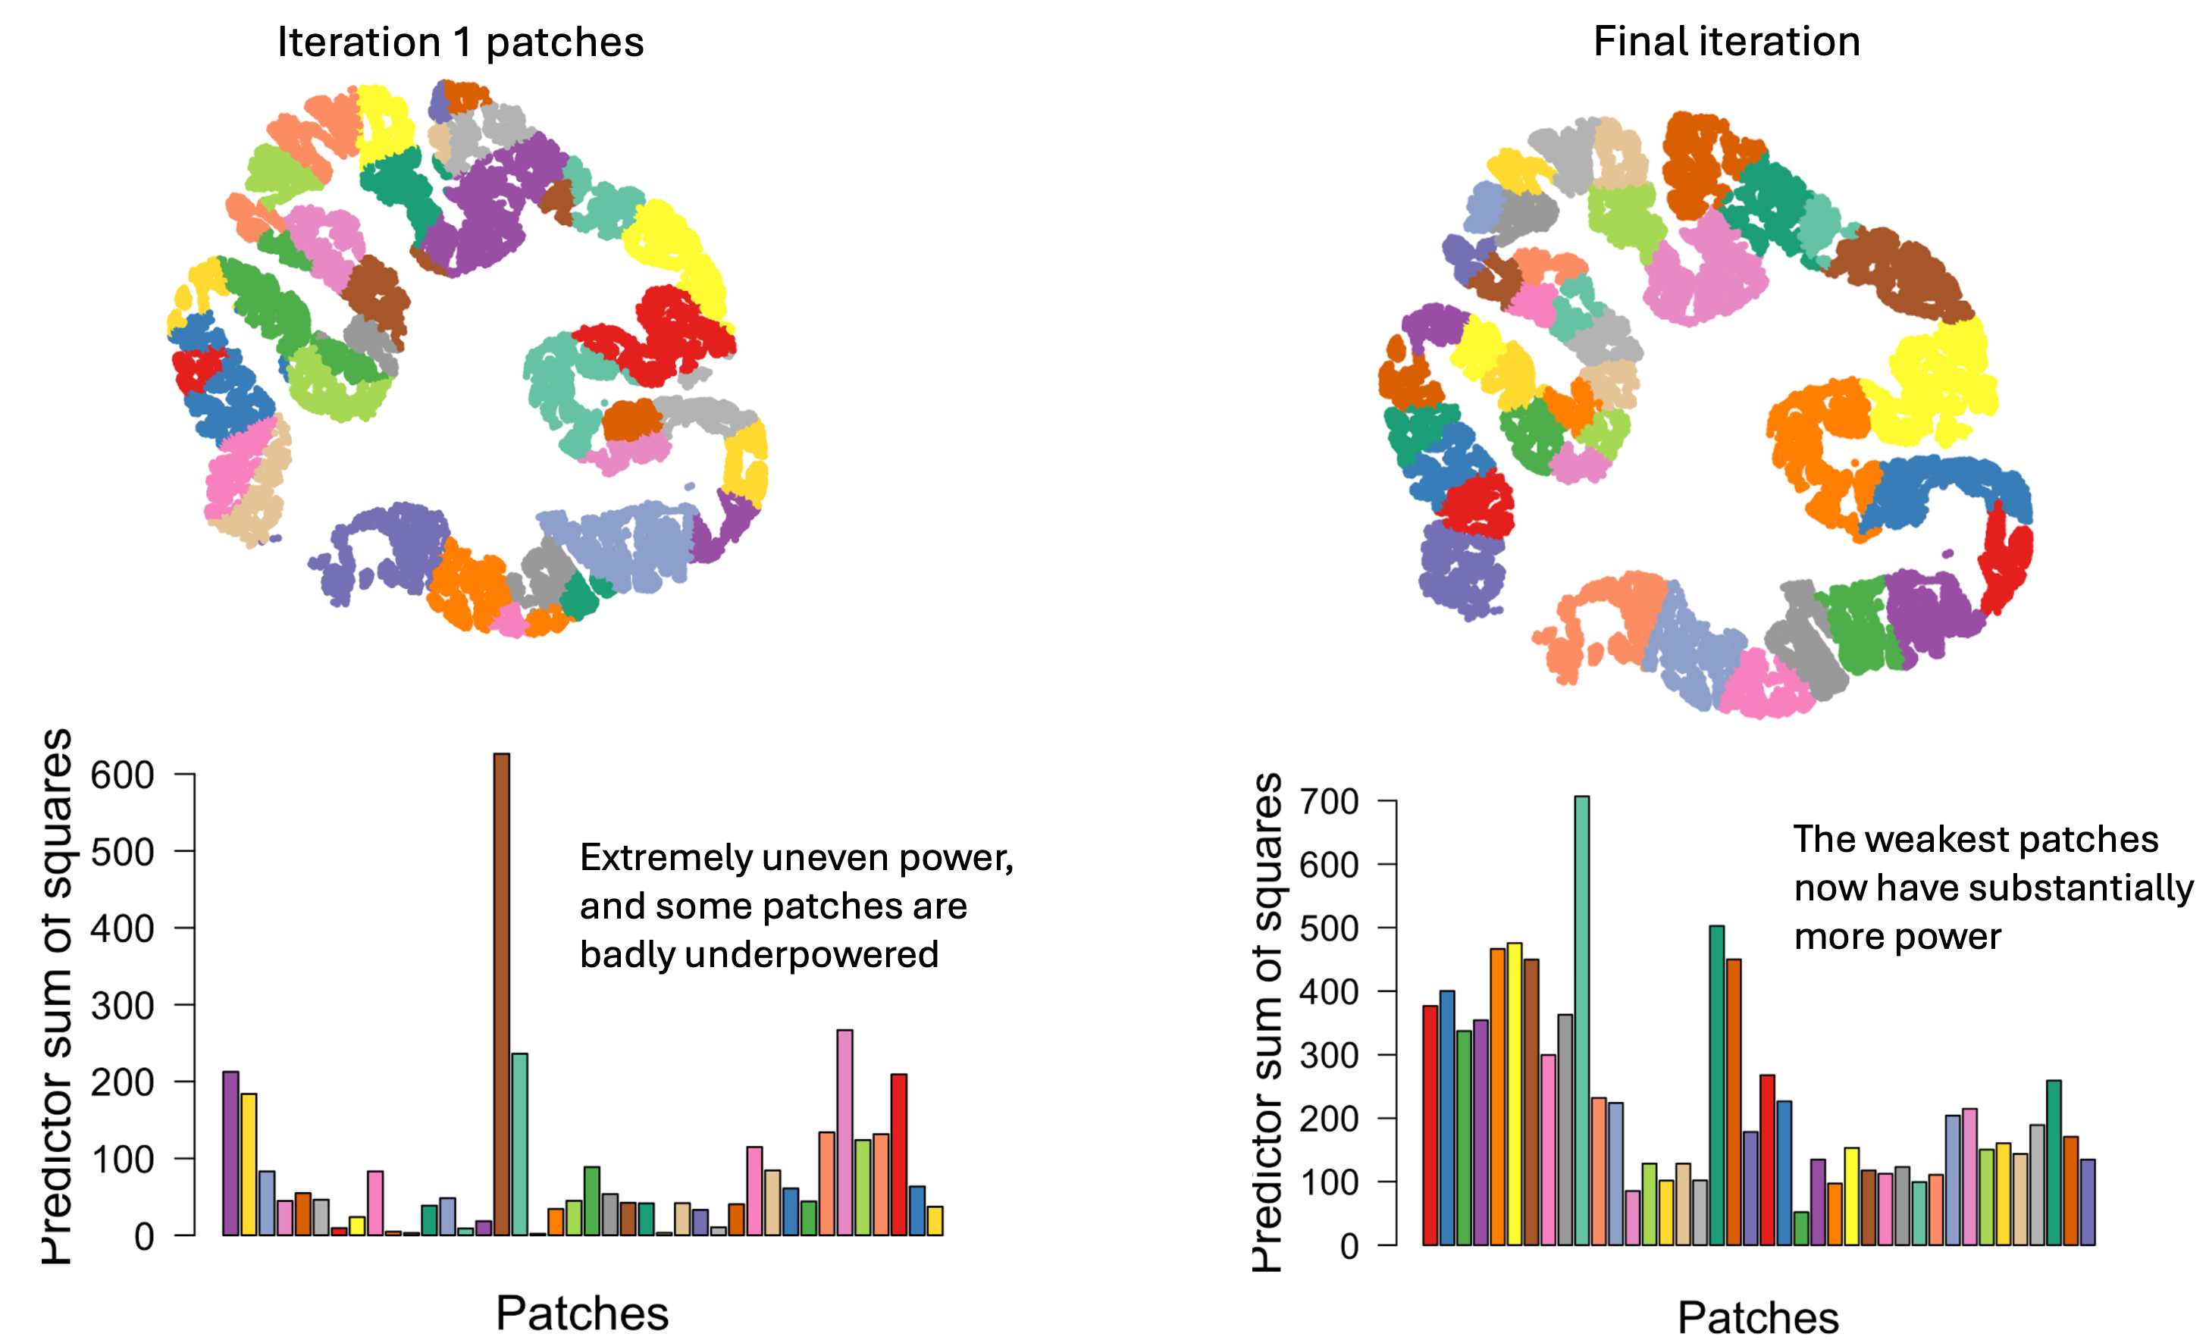
Figure 7: Improvement of patch power over getPatches() iterations on mouse colon epithelial cells. Top panels show patch footprints at first and final iterations; bottom panels show each patch’s sum of squares of the predictor variable.

4.3.2 Smoothed patch meta-analysis improves statistical power
Figure 8 compares per-patch DE results before and after meta-analysis in the colon-cancer sample dataset²³. Left: $t$-statistics from single-patch DE on a single gene. Right: $z$-statistics from meta-analysis on each patch’s 15 most comparable patches (nearest neighbors in patch-composition space).
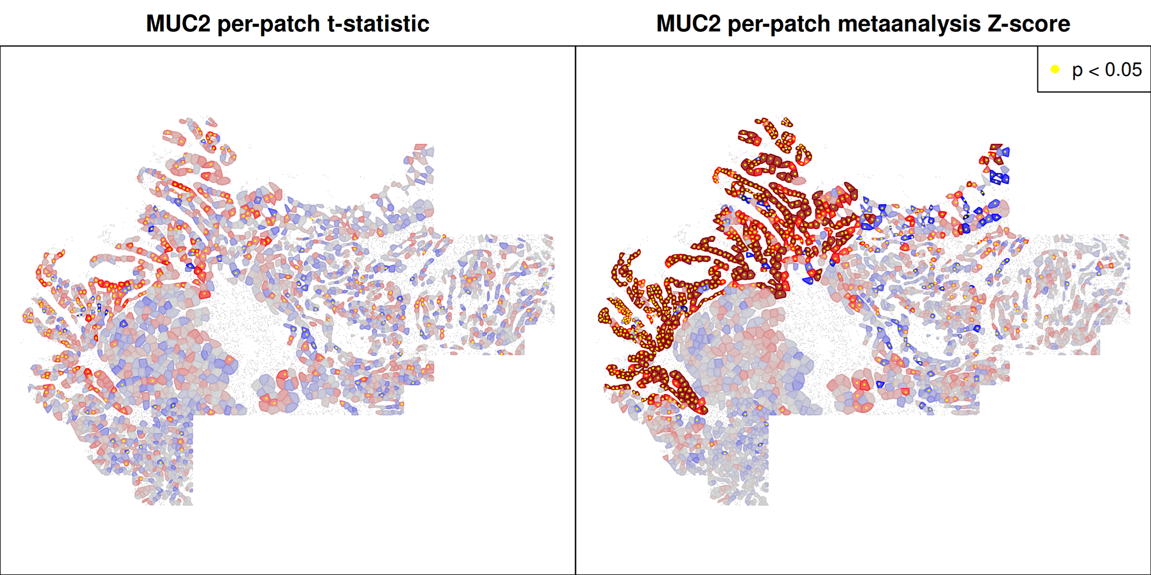
Figure 8: Single-patch versus meta-analyzed DE in the colon-cancer sample. Left: $t$-statistics from single-patch DE for one gene. Right: $z$-statistics from meta-analysis across each patch’s 15 nearest neighbors in patch-composition space.

4.4 Discussion and next steps
The approach is not limited to differential expression. Any method that produces a summary statistic and a standard error can be stratified across patches and subjected to the same meta-analysis workflow.
Several deep questions remain open. Is this a hypothesis-testing framework or an exploratory framework? How should the analysis account for dependence structures among patches? How should multiple-testing correction work when neighborhoods overlap? The methodological roadmap centers on these issues alongside more practical refinements: recommendations and utility functions for defining patch characteristics, vignettes for interpreting subgroup results, an accounting for non-independence among patches (cf. the metapod package), an alternative formulation in which a patch’s neighbors serve as a prior that the patch’s own data updates, and clustering of genes and patches by per-patch DE profile.
On the code and packaging side, planned work includes a dedicated meta-analysis function, a Bioconductor wrapper for the pipeline, convenience functions for patch-characteristic construction, a data package suitable for LLM-driven exploration, and vignettes and case studies. Two outstanding decisions are whether the framework is best positioned as hypothesis-testing or exploratory — diagnostics will follow from that choice — and the final package name (working title: SpaceMosaic).
The ultimate goal is to enable nuanced, confident statements like “[cell type] up-regulates [gene] in response to [X] in spatial regions with [these characteristics]” — without worrying that the result is an artifact of cryptic confounding. Defining the right post-hoc statistics and diagnostic plots to support that claim is ongoing work.

5. Enhanced infrastructure and interoperability for spatial omics data in Bioconductor
Source code:
- SpatialData — R interface to Python’s spatialdata
- SpatialData.data — example datasets
- SpatialData.plot — visualization
- VeniceInterop — end-to-end workflow and relationships prototype

5.1 Motivation
Modern spatial-omics platforms produce data that are increasingly authored, stored, and pre-processed in the Python scverse ecosystem (notably the spatialdata and AnnData packages), while Bioconductor remains the natural downstream environment for many statistical and biological analyses. Without a faithful bridge between the two, users either duplicate infrastructure or choose one ecosystem at the cost of tools that live in the other. The work described here closes that gap by extending the R SpatialData package and its companions into a complete reader, writer, and analysis surface compatible with the Python representation, and by demonstrating end-to-end workflows that mix R and Python tools on a single dataset.

5.2 Methods
The SpatialData family of R packages implements a faithful R-side representation of the Python spatialdata format and adds the lazy access patterns required to work with it at scale. The methods below describe the storage layers and their R readers, the companion data and visualization packages, and the lazy spatial-subsetting pattern that recurs across analyses.

5.2.1 Storage layers and reader path
Python’s spatialdata framework is a standardized format for spatial omics, storing data as .zarr files using an extension of the OME-NGFF specification². The R SpatialData package provides an R interface to spatialdata and integrates the resulting representations into the Bioconductor ecosystem. Image and label elements (e.g., microscopy and rasterized segmentation results) are represented as .zarr-backed ZarrArrays via the Rarr package. Point elements (e.g., transcripts) and shape elements (e.g., cell or nucleus boundaries) are stored in .parquet and represented as lazy data frames via duckspatial. Table elements (e.g., shape annotations) are represented as SingleCellExperiment objects, read directly from AnnData via anndataR²⁴.
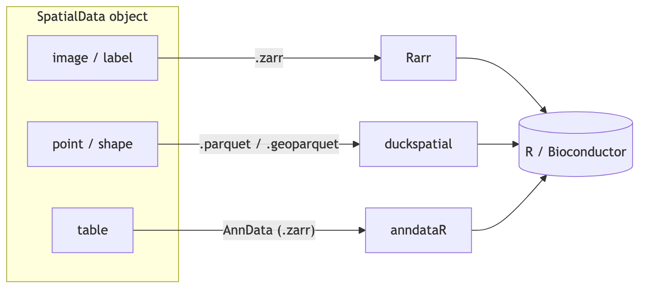
Figure 9: Storage and reader path for each SpatialData element type. Images and labels are .zarr-backed; points and shapes are .parquet-backed; tables are read from AnnData/.zarr.
Because tabular information lands in SingleCellExperiment, interoperability with Bioconductor’s existing single-cell infrastructure is preserved. The on-disk representations of the other components support efficient lazy access via Rarr and duckspatial. Available functionality includes spatial queries by rectangular bounding box or polygon, and masking between elements to aggregate information across layers.

5.2.2 Companion packages
Two companion packages provide modular SpatialData infrastructure. SpatialData.data supplies toy and realistic example datasets (sequencing- and imaging-based), and SpatialData.plot handles visualization — including layered plots that overlay segmentation, mRNA molecules, and high-plex or histopathology imagery. An online gallery is under active development at https://helenalc.github.io/SpatialData.

5.2.3 Lazy spatial subsetting via duckspatial
Spatial subsetting emerged as a fundamental, recurring operation across analyses. These operations apply to potentially very large on-disk data — millions of transcript points or cells — and must avoid materializing the whole dataset in memory. The implementation uses duckspatial, which exposes the spatial extension of DuckDB from R: spatial filtering is compiled to SQL and executed by the database engine, loading only the matched rows. For example, transcripts overlapping a selected cell or within a region of interest can be efficiently extracted from a Parquet file with hundreds of millions of rows. Query regions can be rectangular bounding boxes or arbitrary polygons. This pattern is now used by the query method for both points and shapes in SpatialData.

5.3 Results
The work delivered an end-to-end interoperability demonstration that crosses the Python/R boundary on a single dataset, plus a prototype redesign of how relationships across SpatialData elements are encoded and explored.

5.3.1 End-to-end workflow
To demonstrate the current capabilities and interoperability with existing R/Bioconductor tools, an end-to-end workflow was built that reads results from SegTraQ — a Python framework for cell segmentation and transcript-assignment QC — into R, applies two downstream analyses (RCTD-based signal purity scoring via spacexr²⁵ and delineation of multicellular anatomical structures via sosta²⁶), and visualizes the results spatially with SpatialData.plot. The full workflow — read data written by Python’s spatialdata, compute QC scores and anatomical structures, visualize subsets — is summarized in Figure 10, with image-specific visualization shown in Figure 11. An R Markdown source plus rendered HTML is published at https://github.com/HelenaLC/VeniceInterop.
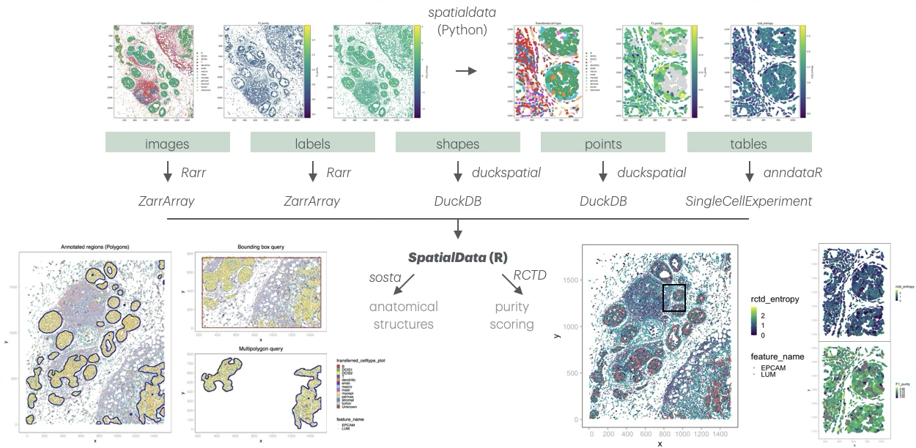
Figure 10: Schematic overview of SpatialData in R. Top to bottom: SpatialData objects comprise five layers (images, labels, shapes, points, and tables). Images and labels are .zarr-backed and read with Rarr; shapes and points are .parquet-backed and read with duckspatial; tables are read from .zarr via anndataR. Existing R/Bioconductor methods for spatial omics analysis remain interoperable — for example, sosta for multicellular structure delineation (left) and RCTD via spacexr for deconvolution, used here as a proxy for signal contamination.

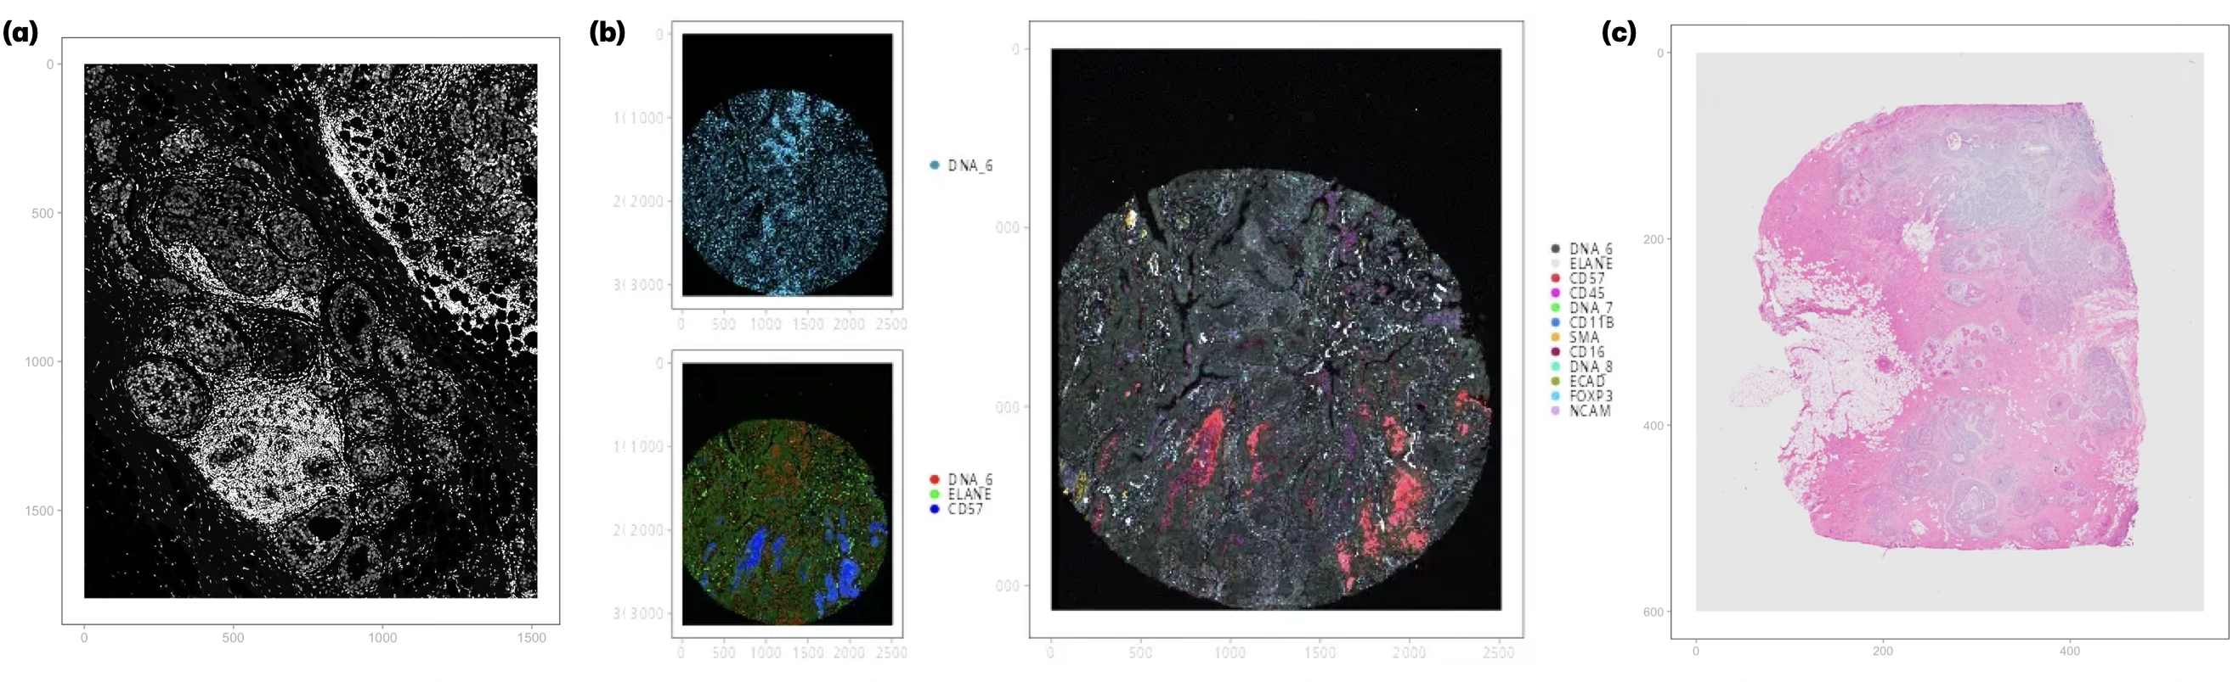
Figure 11: Demonstration of SpatialData.plot image-visualization capabilities. (a) Greyscale image of the dataset shown in Figure 10. (b) Top-left: a 1-channel image with a user-configurable color. Bottom-left: 3-channel images mapped to RGB (user-configurable). Right: a 12-channel image mapped to RGB based on user-defined per-channel colors. Images in (b) are derived from a 12-plex proteomics (MCMICRO) lung adenocarcinoma dataset²⁷ from SpatialData.data. Contrasts are auto-adjusted across all images using 5%-percentile clipping. (c) Exemplary H&E staining from a Visium (10x Genomics) breast-cancer dataset²⁸.

5.3.2 Relationships across SpatialData elements
As a side project, a new design for encoding and exploring relationships across SpatialData elements — both within and across SpatialData objects — was prototyped. Improving the design and exploration of relationship metadata is a prerequisite for broader adoption across packages and languages. The prototype was illustrated on the same Xenium subset used above, complemented with four additional SpatialData objects covering further modalities, and accompanied by an interactive viewer (graph_all.html); the code is in https://github.com/HelenaLC/VeniceInterop/tree/main/relationships.
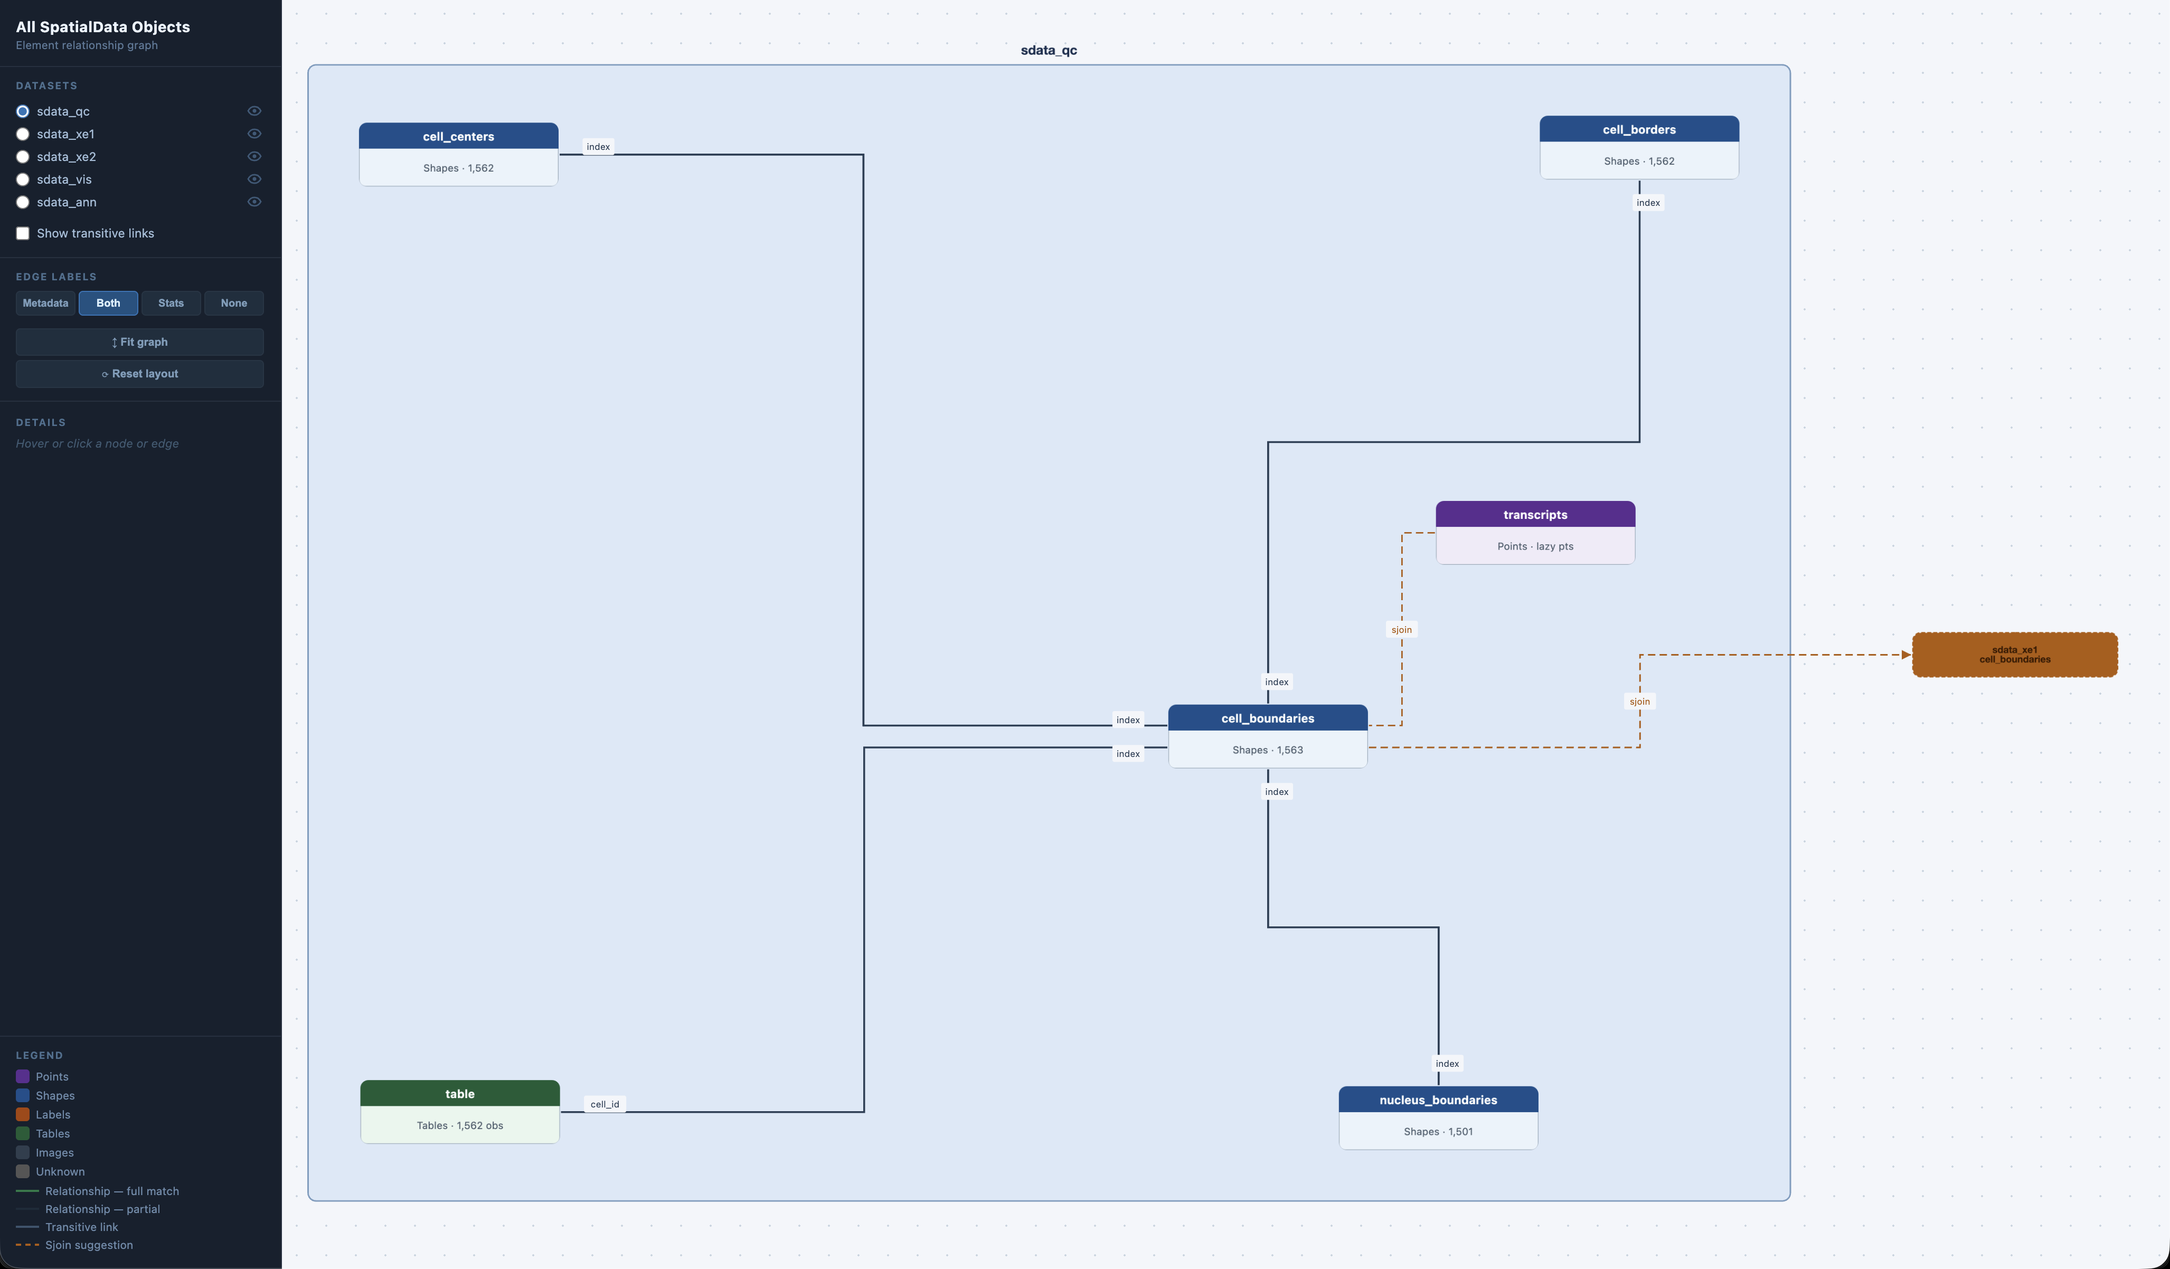
Figure 12: Prototype interactive explorer of relationships across SpatialData objects, demonstrating the new relationship-encoding design on a multi-modal Xenium dataset.

5.4 Discussion and next steps
R SpatialData development began more than two years ago²⁹, but full functionality awaited several infrastructural pieces — notably delayed .zarr support and AnnData interoperability. The hackathon delivered three concrete advances: lazy handling of points (from .parquet) and shapes (from .geoparquet) via duckspatial; demonstrated interoperability with existing R/Bioconductor tools for spatial omics analysis; and improved visualization in SpatialData.plot, with an approximately ten-fold speedup and automatic contrast adjustment.
Continued co-design with the Python spatialdata developers is essential to keep the two ecosystems coherent as both evolve. Priorities for the next phase are upstreaming the relationship-encoding prototype, expanding the example gallery to cover additional modalities and analysis patterns, and validating the lazy-query pattern on the largest available datasets where its memory advantages should be clearest.

6. Discussion
The four projects reported here address complementary layers of the spatial-omics stack. Team 1 tackled the raster–polygon bottleneck that has historically kept R/Bioconductor away from gigapixel digital pathology, and shows that pairing OME-Zarr with GeoParquet and pushing spatial queries to DuckDB makes whole-slide analysis tractable on a laptop. Team 2 lowered the bar for using spatial foundation models from R by isolating each model in its own Python environment and exposing a uniform Run_*() interface, turning what is currently a per-model setup project into a package install. Team 3 prototyped a spatially stratified differential expression framework that lets the location of an effect, not just its magnitude, become a first-class output of an analysis. Team 4 demonstrated end-to-end interoperability between Python’s spatialdata and the R SpatialData family, with duckspatial-backed lazy queries and large gains in visualization performance.
A consistent theme across teams is that the hard problem in scaling spatial analysis is not algorithmic but representational: choosing on-disk formats and access patterns that let the rest of the toolchain stay expressive and interactive. GeoParquet, OME-Zarr, and DuckDB recur because they let R code stay declarative while pushing the heavy lifting to indexed, chunked storage.
Several open questions remain. The patch-stratified DE framework needs to clarify whether it is best framed as hypothesis testing or as an exploratory tool, and to settle on the right multiple-testing model for non-independent neighborhoods. The foundation-models package has to handle models that are not on PyPI without forcing every user to provision their own environment. The SpatialData infrastructure work needs continued co-design with the Python spatialdata developers to keep the two ecosystems coherent.
All software produced during the hackathon is open and under active development; we welcome contributions, issues, and use cases from the community.

7. Code and data availability
All software developed during the hackathon is hosted in public GitHub repositories linked from the relevant team sections; those repositories remain the active development homes. A consolidated snapshot of the work as it stood at the close of the hackathon, organized by team into per-project folders, is also available at https://github.com/BiocCodingCollaborations/VeniceHackathon2026.

8. Author contributions
H.C., L.M., W.H., and D.R. organized and led the hackathon. S.D. coordinated the production of the preprint manuscript. All authors participated in one or more team projects and contributed to the manuscript.

9. Use of AI tools
Claude (Anthropic, model claude-opus-4-7) was used to convert team-authored Google Docs into this Quarto project, scaffold the CI/CD workflow, and propose structural edits — including the table in Table 2 and the diagrams in Figure 9 and Figure 6. The authors reviewed all AI output and retain full responsibility for the manuscript’s content.

10. Acknowledgements
The event was organized by the Department of Statistical Sciences of the University of Padova in collaboration with Venice International University. It was funded in part by the European Research Council (ERC) Grant CoG 101171662 and supported by EMBL’s Transversal Theme Theory@EMBL. We thank Elena Guzzonato for her help with the organization of the event. S.D. acknowledges support from NCI U24CA289073. R.C. and P.M-S. acknowledge support from grants PID2024-158127NB-I00 funded by MICIU/AEI /10.13039/501100011033 and by “ERDF: A way of making Europe”, and 2022-311145 funded by the Chan Zuckerberg Initiative DAF, an advised fund of Silicon Valley Community Foundation.
1. The Cancer Imaging Archive. The cancer genome atlas ovarian cancer collection (TCGA-OV). (2013) doi:10.7937/K9/TCIA.2013.V7FRLZ1D.
2. Marconato, L. et al. SpatialData: An open and universal data framework for spatial omics. Nature Methods https://doi.org/10.1038/s41592-024-02212-x (2024) doi:10.1038/s41592-024-02212-x.
3. Pebesma, E. Simple features for r: Standardized support for spatial vector data. The R Journal 10, 439–446 (2018).
4. Baddeley, A. & Turner, R. spatstat: An R package for analyzing spatial point patterns. Journal of Statistical Software 12, (2005).
5. Billato, I. imageTCGA: TCGA Diagnostic Image Database Explorer. (2026). doi:10.18129/B9.bioc.imageTCGA.
6. Graham, S. et al. Hover-net: Simultaneous segmentation and classification of nuclei in multi-tissue histology images. Medical Image Analysis 58, 101563 (2019).
7. Hijmans, R. J., Brown, A. & Barbosa, M. terra: Spatial Data Analysis. (2026). doi:10.32614/CRAN.package.terra.
8. Cidre González, A., Kotov, E. & Pereira, R. H. M. duckspatial: R Interface to ’DuckDB’ Database with Spatial Extension. (2026). doi:10.32614/CRAN.package.duckspatial.
9. Pagès, H., Smith, M., Gruson, H. & Manukyan, A. ZarrArray: Bring Zarr Datasets in R as DelayedArray Objects. (2026). doi:10.18129/B9.bioc.ZarrArray.
10. Pagès, H. DelayedArray: A Unified Framework for Working Transparently with on-Disk and in-Memory Array-Like Datasets. (2026). doi:10.18129/B9.bioc.DelayedArray.
11. Sievert, C. et al. plotly: Create Interactive Web Graphics via ’Plotly.js’. (2024).
12. Petukhov, V. et al. Cell Segmentation in Imaging-Based Spatial Transcriptomics. Nature Biotechnology vol. 40 345–354 (2022).
13. MerfishData. Bioconductor (2026).
14. Hernangómez, D. Using the Tidyverse with Terra Objects: The Tidyterra Package. Journal of Open Source Software vol. 8 5751 (2023).
15. Cui, H. et al. scGPT: Toward building a foundation model for single-cell multi-omics using generative AI. Nature Methods 21, 1470–1480 (2024).
16. Hao, M. et al. Large-scale foundation model on single-cell transcriptomics. Nature Methods 21, 1481–1491 (2024).
17. Quentin, B., Hakim, B., Nadège, B., Fabrice, A. & Paul-Henry, C. Novae: A graph-based foundation model for spatial transcriptomics data. bioRxiv https://doi.org/10.1101/2024.09.09.612009 (2024) doi:10.1101/2024.09.09.612009.
18. Xu, H. et al. A whole-slide foundation model for digital pathology from real-world data. Nature 630, 181–188 (2024).
19. Rumberger, J. L. et al. Automated classification of cellular expression in multiplexed imaging data with nimbus. Nature Methods 22, 2161–2170 (2025).
20. Shaban, M. et al. A foundation model for spatial proteomics. arXiv preprint arXiv:2506.03373 (2025).
21. Wang, C. et al. scGPT-spatial: Continual pretraining of single-cell foundation model for spatial transcriptomics. bioRxiv 2025–02 (2025).
22. Cadinu, P. et al. Charting the cellular biogeography in colitis reveals fibroblast trajectories and coordinated spatial remodeling. Cell 187, 2010–2028.e30 (2024).
23. Crowell, H. L. et al. Tracing colorectal malignancy transformation from cell to tissue scale. bioRxiv 2025.06.23.660674 (2025) doi:10.1101/2025.06.23.660674.
24. Deconinck, L. et al. anndataR improves interoperability between R and Python in single-cell transcriptomics. bioRxiv 2025.08.18.669052 (2025) doi:10.1101/2025.08.18.669052.
25. Cable, D. M. et al. Robust decomposition of cell type mixtures in spatial transcriptomics. Nature Biotechnology 40, 517–526 (2022).
26. Gunz, S., Crowell, H. L. & Robinson, M. D. Analysis of multicellular anatomical structures from spatial omics data using sosta. bioRxiv https://doi.org/10.1101/2025.10.13.682065 (2025) doi:10.1101/2025.10.13.682065.
27. Schapiro, D. et al. MCMICRO: A scalable, modular image-processing pipeline for multiplexed tissue imaging. Nature Methods 19, 311–315 (2022).
28. Janesick, A. et al. High resolution mapping of the tumor microenvironment using integrated single-cell, spatial and in situ analysis. Nature Communications 14, 8353 (2023).
29. Marconato, L. et al. 1st SpatialData developer workshop. https://doi.org/10.37044/osf.io/8ck3e (2024) doi:10.37044/osf.io/8ck3e.

